The first input and out put.

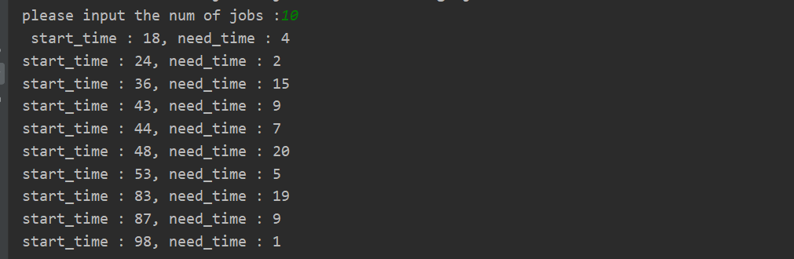

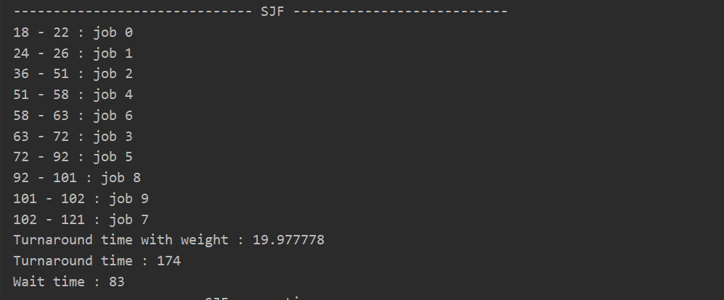

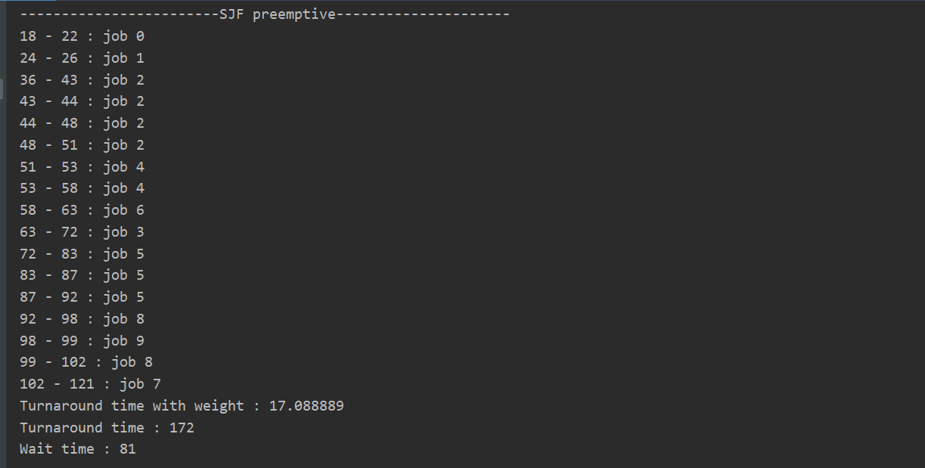

The second input and out put.

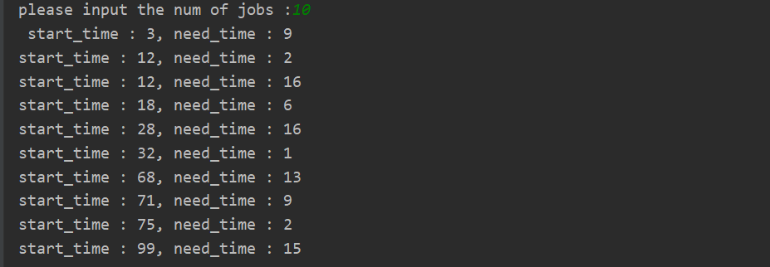

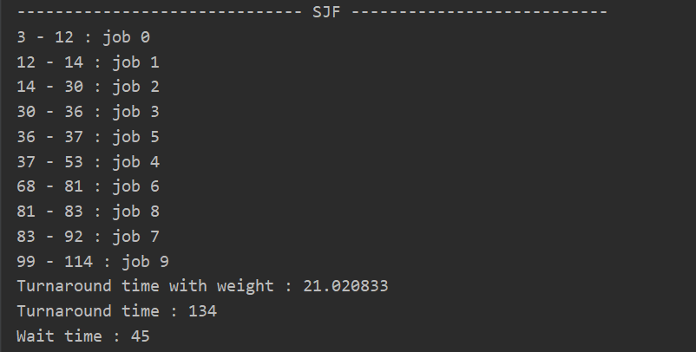

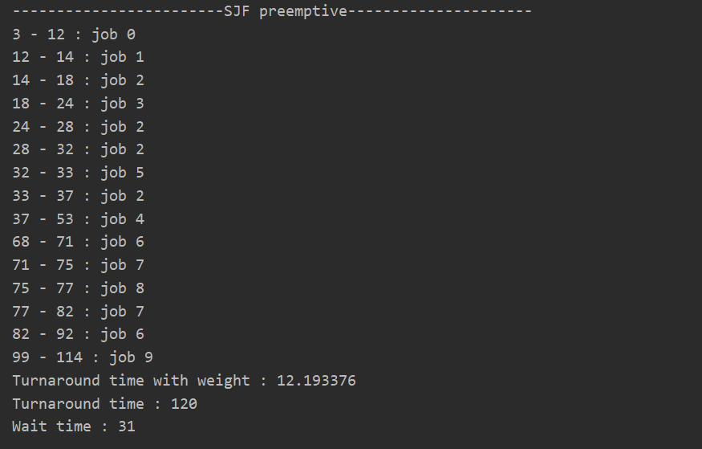

Code idea : For the non-preemptive short job priority scheduling algorithm, the idea is relatively simple: find the job with the shortest time in each cycle and run it until all jobs have been completed. For preemptive short job scheduling, in each cycle, first find the job with the shortest remaining time, and then determine whether it can be completed before the next job arrives. If it can be completed, finish the job directly; otherwise, restart the next cycle when the next job arrives.

According to the output results, preemptive scheduling is better than non-preemptive scheduling in weighted turnaround time, turnaround time and waiting time. Preemptive scheduling is more conducive to short jobs and can further reduce the total waiting time.